Process for Monitoring, Measurement, Analysis and Evaluation

Security Classification: Restricted

Document Reference: ISMS09005
Version: 1.0
Draft 1

Document Author: PMO

Document Owner:PMO

Revision History

Version | Date | Change Number | Summary of Changes
1.1 | 30 Nov 23 | Draft 1 | Tailoring to PMO
1.2 | Feb 24 | Draft 1 | IE Review
1.3 | Feb 24 | Draft 1 | Legal Review
1.4 |  | Draft 1 | Unit Sign-off
2.0 |  | Version 2 | Management Sign-Off

Document Review

Date of Next Scheduled Review

Distribution

Name | Title
Bukola Omoniyi | Officer in Charge Project management
Abubakar Sadiq | Project Management
Oliver Nnona | Independent Expert
MJ Abubakar | Officer in Charge, Cybersecurity
Maduka Emelife | Independent Expert
Uche I Egolum | NCS Legal

Approval

Name | Position | Signature | Date

Contents

1 Introduction 5
2 Process Overview 6
3 Monitoring and Measurement 7
4 Analysis and Evaluation 10

Introduction

An effective Information Security Management System (ISMS) helps to provide Project Management Office (PMO) with a good degree of protection against risk from threats to the confidentiality, integrity, and availability of its information assets. The ISO/IEC 27001 standard requires that we evaluate the information security performance and the effectiveness of the ISMS so that we know if it’s doing a good job for the service.

This document sets out the approach that the Project Management Office (PMO) will take to monitoring and measuring its ISMS and how it will interpret the results to prompt any required actions for improvement.

Definition of Key Terms

Monitoring in refers to the continuous and systematic observation, analysis, and assessment of PMO IT infrastructure, networks, applications, and digital assets to detect and respond to security threats and incidents. The primary goal of monitoring is to maintain the confidentiality, integrity, and availability of information, as well as to ensure the overall security posture of the Service.

Measurement refers to the systematic process of quantifying, evaluating, and assessing various aspects of PMO information security program to gauge the effectiveness, identify vulnerabilities, and ensure compliance with security policies and standards. This process involves the use of metrics, key performance indicators (KPIs), and other quantitative methods to provide insights into the security posture, risk levels, and the overall resilience against cyber threats.

Analysis refers to the systematic examination and interpretation of information, data, events, or activities to gain insights into the security posture of the PMO, identify potential threats, assess risks, and make informed decisions. This process involves using various analytical methods, tools, and techniques to understand the nature, scope, and implications of cybersecurity incidents, vulnerabilities, and overall security operations.

Process Overview

The overall process for the monitoring, measurement, analysis, and evaluation of the performance of the ISMS is shown below. This process is followed whenever a new requirement to measure the performance of the ISMS is identified.

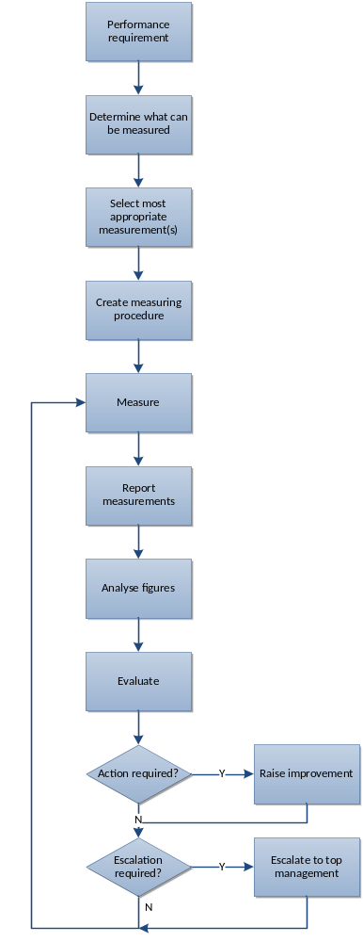

Figure 1 – Process for Monitoring, Measurement, Analysis and Evaluation

Monitoring and Measurement

There are many potential ways in which we can attempt to measure whether we are maintaining a good governance regime and are implementing our controls in a way that genuinely reduces risk. Some of these ways are easy to do and some are very much harder; some are straightforward to interpret and others require a lot more effort to understand what the figures may mean.

The challenge is to define a monitoring and measurement regime that gives us the answers we want without creating an administrative headache in collecting and interpreting the data.

In order to do this, we need to define:

- what will be monitored and measured
- when and how the monitoring and measurement will be carried out
- when and how the results will be analysed and evaluated
- who will do each of the above
- what evidence we will keep of the monitoring and measurement results

The table on the following page defines an initial starting point for the areas of the ISMS that will be monitored and measured and in broad terms how this will be done. For the more complex of the metrics listed a procedure will be created which will detail how the information is collected, including the rules used for what is counted and what is not.

For example, in determining the financial cost of an incident, which of the following aspects are to be included in the calculation:

- costs of initial incident response, including callouts
- cost of downtime of systems
- cost of reputational damage
- lost business
- fines resulting from data loss.

The rules must be defined in enough detail to allow fair comparisons to be made between incidents and over time.

Area Monitored | Metric | Collection method | Collection frequency | Who collects | Where stored
Security incidents | Number of security incidents, by severity | Via incident management process | Continuous | Cybersecurity unit/ Network and Telecommunication | Firewall and Security incidence register (SIEM)
Risks | Number of risks, by priority | IT risk register | Quarterly | Cybersecurity unit | IT Risk management spreadsheet
Threats | Number of new threats notified | Via authorities and special group contacts | Quarterly | Cybersecurity unit | Threat register
Vulnerabilities | Number of new vulnerabilities detected | As a result of regular penetration testing | Quarterly | Cybersecurity unit/External third party | Penetration test reports
Information assets | Number of information assets, by classification | Asset inventory tools/site visits | Every 6 months | Cybersecurity unit | IT Asset register
Change Management | Number of changes | Change Management system | Quarterly | Project Management Unit | PMU Repository
Training | Number of training days received | Recorded in employee training records | Continuous | Project Management Unit | PMU Repository
Awareness | Number of people attending awareness sessions | Headcount at each session | Quarterly | Cybersecurity unit | Cybersecurity Awareness Training file
Improvements | Number of improvements identified | Via improvement process | Continuous | Project Management Unit | Improvement action log
Non-conformities | Number of non-conformities identified | ISMS Audit reports | Every 6 months | Cybersecurity unit | ISMS Audit Files
Network users | Record of registered users, by application | Reports from firewall | Quarterly | NTU | Network Users File

Table 1 – Areas to be monitored and measured.

Analysis and Evaluation

In analysing and evaluating the results of the monitoring and measuring activities described in the above table it is important the right people are involved so that the correct interpretation can be reached.

The main method of presentation of performance information regarding the ISMS will be the management review spreadsheet. This will contain the summarised data from the measurements and will present the information graphically where possible. The Cybersecurity unit is responsible for the preparation of the management review spreadsheet.

Conclusions reached from the analysis and evaluation will be minuted and where appropriate improvement actions will be raised in the ISMS improvement action log.

Where necessary, urgent issues will be escalated to top management in order to ensure that sufficient resources are made available to address them.

Further metrics may be defined which will help to clarify the causes of issues in particular areas. These will be added to the table above and suitable procedures created if required.

